“Duke”
CH Boulder’s N Solterra’s Beginning To See The Light
The Woodlands, Texas
Sire- BIS 3XRBIS 27XBISS 2XNBIS Platinum GCH Regal Point Pinnacle of Kileaua MH CGC ROM
Dam- GCH Boulder’s N Fusion’s Soul de mi Corazon
DOB- 8/7/2015
Breeder- Erica and Spencer Sparrow
Co-breeder- Judy and Edj Hetkowski
Handler- Karen Newman
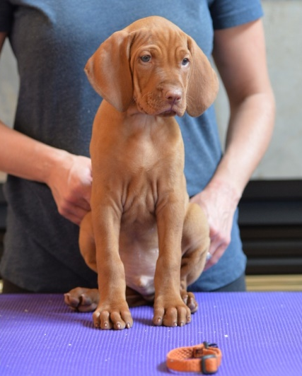
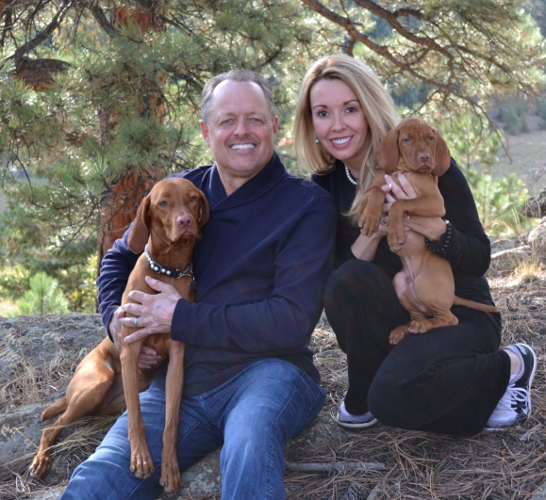
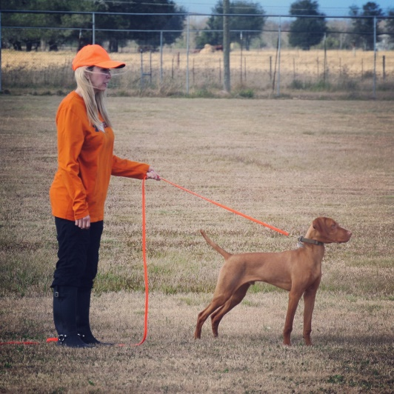

Performace Highlights
- 2016 VCA Nationals-
  - 6-9 month Futurity- 1st place
  - 6-9 month class- 4th place
- Championship
  - Finished show championship days after turning 10 months old
  - Finished with 4 MAJORS in 4 weekends
  - Solterra’s first homebred champion

